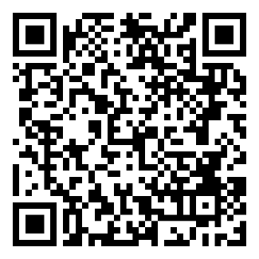
Neurology Grand Rounds
Sponsored and Coordinated by The Department of Neurology and The Office of Continuing Medical Education
Thursday, August 6, 2026 Join Meeting Now
12:00-1:00 pm (Lunch will be served while supply last)
Location: The Pavilion (Room 2), 801 Clinic Drive, Tyler

Late-Onset Epilepsy of Unknown Etiology: A Window into Brain Aging and Neurodegenerative Disease

Speaker:
Niyatee Samudra, MD
Clinical Assistant Professor of Neurology
Director, Senior Epilepsy Clinic
Divisions of Epilepsy and Memory Disorders
Stanford University School of Medicine

Objectives:

At the end of this presentation, participants should have increased information to:

- Recognize the clinical presentation, diagnostic evaluation, and management considerations of late-onset epilepsy in older adults.
- Describe the emerging relationship between late-onset epilepsy of unknown etiology (LOUE) and cognitive decline, including potential links to neurodegenerative disease.
- Discuss current evidence regarding the impact of seizures and network hyperexcitability on cognition and dementia risk in aging populations.

Neurology Grand Rounds are designed for Neurology, Transitional Year, Internal Medicine, Psychiatry, and Family Medicine physicians, residents, and medical students.

The University of Texas at Tyler Health Science Center is accredited by the Texas Medical Association to provide continuing medical education for physicians.
The University of Texas Health Science Center at Tyler designates this live educational activity for a maximum
of 1.0 AMA PRA Category 1 creditTM. Participants should only claim credit commensurate with the extent of
their participation in the activity.

ABIM MOC Credit
Successful completion of this CME activity, which includes participation in the evaluation component, enables the participant to earn up to one (1) MOC point in the American Board of Internal Medicine’s (ABIM) Maintenance of Certification (MOC) program. Participants will earn MOC points equivalent to the amount of CME credits claimed for the activity. It is the CME activity provider’s responsibility to submit participant completion information to ACCME for the purpose of granting ABIM MOC credit.

